**國立東華大學資訊工程系**

**National Dong Hwa University**

107學年度大學部專題研究報告

107 CSIE Project Report

**\*\*NDHU Event System\*\***

指導教授Advisor： Professor Lai ( 賴志宏)

專題參與人員Team Members： Elsy Sofia Lopez

Andres Obregon Martinez

中 華 民 國　　107　 　年　　05　　月 　 　22 日

**國立東華大學資訊工程學系**

**專題報告原創性聲明**

**National Dong Hwa University**

**Department of Computer Science and Information Engineering**

**Statement of Originality**

本人鄭重聲明：

所呈交的專題報告是在指導老師指導下進行的研究工作及取得的研究成果。除文中已經註明引用的內容外，本報告不包含任何其他個人或集體已經發表或撰寫過的研究成果。對本文的研究做出重要貢獻的個人與集體，均已在文中以明確方式標明。若有違上述聲明，願依校規處分及承擔法律責任。

I hereby affirm that the submitted project report is the result of research under the supervision of my advisor. Except where due references are made, the report contains no material previously published or written by another person or group. All significant facilitators to the project have been mentioned explicitly. Should any part of the statement be breached, I am subject to the punishment enforced by the University and any legal responsibility incurred.

|  |  |  |
| --- | --- | --- |
| 學號Student No. | 學生姓名Name | 親筆簽名Signature |
| 410321161 | Elsy Sofia Lopez |  |
| 410321166 | Andres Obregon |  |

日 期 Date :107　 　年　　05　　月 　 　22 日

**Abstract**

Keywords: NDHU, events, activity.

As foreigner students in NDHU we can relate and understand what it feels like being in an unfamiliar environment trying to do your best in school and in life in general but finding yourself always struggling to keep up with whatever is going around at the moment or will be happening soon.

As of right now, NDHU does not have a centralized platform that allows students to be aware of the events happening on campus or related to school: speeches, workshops, competitions, shows, just to mention some of them. The only way school officially notifies students is through school’s email, but from personal and friends experience we can tell how overwhelming and confusing it may be that system, especially for foreigner students since most of the times the emails are only in chinese. Therefore, most of them just disregard the email and miss the information.

NDHU Event System is a platform created with the intention of allowing all the students in NDHU to know what is happening around them in a more organized and visually simple way so that they don’t miss any important event or activity relating their learning process, education, recreation, etc.

Our project consists of a site in which students, teachers or faculty can sign up to by using only their school email. After logging in, users are able to navigate through the pages.

Users have been divided so that they can create new activities, modify them or indicate whether they will attend. Each activity shows its name, description, place and time, etc.

All the details about it will be shown later in this document. We hope that through the implementation of this site, students can feel more familiar with what is happening in NDHU and it will make their university life a bit easier.

1. **Contents**

Introduction…………………………………………………………………………. 6

Motivation and Research Problem ………………………………………. 7

Research Method……………………………………………………………….… 8

Research Result ……………………………………………………………….….. 13

Conclusion…………………………………………………………………………... 32

References………………………………………………………………………….. 33

**2. Introduction**

NDHU Event System is about the process, knowledge, technologies and a step-by-step guide of what it our team to get this project done.

Through every stage of the current project, as developer of NDHU Event System, planning and time management skills have been developed along with the most important as communication between the two of us.

Since the beginning, we decided to discuss every decision to make at any stage. This is something that helped us to agree in what direction to take and to contribute with ideas and ways to develop anything in NDHU Event System.

It has been an exciting journey that gave us the opportunity to learn new ways of web developing as well as new technologies.

We would like to thank Professor 賴志宏 for trusting in us as a group and for always giving us support and for his advice on this journey.

Thanks to our friends for their support during the developing of this project.

**3. Motivation and Research Problem**

The purpose of this project “NDHU Event System” is to simplify the big amount of information managed for events in campus.

By using NDHU Event System, all the information regarding future and past activities will be centralized into this system allowing the user access to it at any time. For so many years, we have found out that NDHU students, most of them foreigners, do not go into the email system to look for any event information because there is so much information gathered together which feels overwhelming and since a lot of information is in chinese they give up on trying to know very easily. We decided to develop a system aimed only for all events on campus. It will also give opportunity to be part of any activity staff, in case it’s needed, only to students of NDHU.

In this report, we will introduce and display how to use the different users that are allowed to get into NDHU Event System.

During the developing this project, we intended to put all the knowledge acquired on the last four years of school and at the same time, use our research skills on programming field to get all the information needed.

Through the following parts of the current report: Knowledge, methods, results and discussion, we will use a narrative approach for clearness purposes.

When developing NDHU Event System, we decided to code together, it means, to share every function on our to-do list. We aimed to learn from each other while developing so we both could improve our programming skills while developing.

**4. Research Method**

In order to come up with the idea of NDHU Event System, so many classmates were part of our research to understand how convenient and helpful would it be to have a web system that allows us to get access to organized information of all the events in school?

The first step was to collect all the experience among our classmates in school regarding how frequent they go into email and also review the reasons why this was happening.

Secondly, one thing that all the participants of this research had in common is, even if they wanted to attend, they still wouldn’t go on their mail and look through so many emails and so much information for just one email.

Something that gave us the main idea and direction on which we could work on was that the emails sent by school to every student informing on date, place, and more information regarding the activity was not constant. We found out that there are a couple of activities that does not follow any specific structure, so we decided to create something that forces all of them to do so.

After the research with the people, we still had to do a lot of research to implement all that we had in mind. We had to use some languages, functions, libraries, etc. That we hadn’t learnt or were not familiar with. Most of the research was done through the most popular programming sites as well as CSIE books covering the topic.

In order to systematically introduce NDHU Event System Research section, it is divided into two main stages: Before and after.

Before the actual creation of NDHU Event System, while planning what it would be our Database, we did not have a full understanding of the complications and what we would call extensions of this project. Before NDHU Event System, the group of technologies that were planned to use were:

- HTML5

- CSS3

- jQuery

- Php

- MySQL

After we started to develop the front-end part, we realized that we could not start from scratch and needed a quick solution for basic functions so we could use less JavaScript and leave it to management of data only. And this is when, after discussing it, we decided to use Bootstrap 4 (front-end new technology). Afterwards, we finished one of the many changes to our Database design. So, the next step was to start getting along with the information saved manually. We found out that a powerful tool in order to manage data efficiently and in an easy way is jQuery, ajax and json data structure (background technologies adding). Back and Front End where added one to two technologies each.

When developing front and back end sections, we discussed from the beginning to keep both divided into files.

For the Back-end files, we have used files with php code only having the word “fetch” in their name also with “DB” at the end. These files have been specifically used to get all the queries from the front-end to the Database.

After catching the result of the query, we catch into an array, most of the time, and into a Json object so it can take back to the front-end, that we will see below that is directly taking it into the success or fail result of the Ajax method.

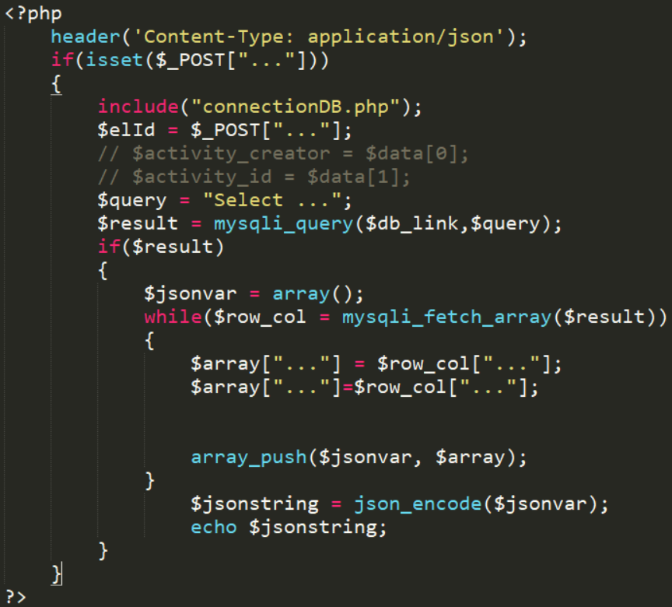

As an example of our back-end code section, we show left, one of the most common structure for the functions used on it. For security purposes, we have deleted database column names and data we consider not proper to display:

Above was shown the most common php & Json function structure used as a model for all the other functions used on this project. After information is caught and managed into a json array, it is sent to front-end file that contains html (as the visual structure and elements visible for the user) with jQuery (code used to handled elements on html code and also to control the information sent from the back-end.

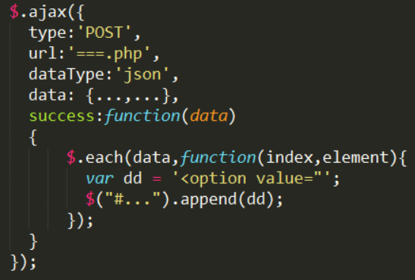A basic structure of ajax function is shown on the right.

For security purposes, data, parameters and variables have been deleted.

very data is received as a success (it was designed that way to avoid the failed function).

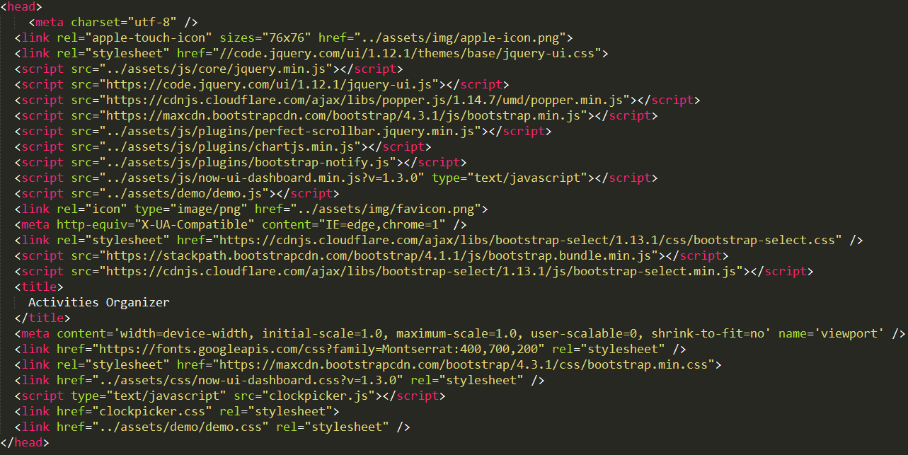Among the tools that we agreed when planning and after a few changes to the structure of NDHU Event System, are shown on the following picture and specifically there are two as “clockpicker” one as JavaScript and the left one as stylesheet that allows us to use the element style from jQuery and also its functionalities in order to choose time for the activity. In the following picture, we show all the JavaScript and that part of it has been downloaded and saved along with our php files and divided into different folders.

One more functionality that we have added to NDHU Event System is the use of Stored Procedures that help us out returning the ID of the data that we have just inserted in order to take the ID and save it into another table. Please look at the image below for reference (for security purposes, the following stored procedure has been modified)

**5. Research Result**

Now we introduce the result of the website:

The Database Design

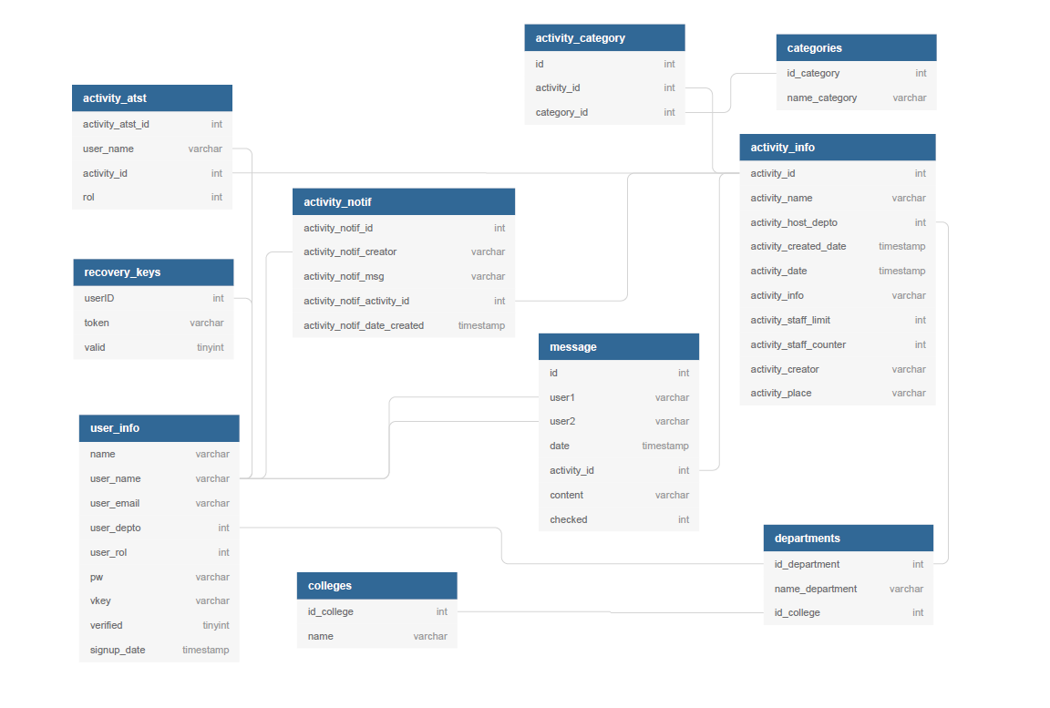

Our Data base counts with 10 tables in total. There is one table only for all the different categories for activities, also for all the colleges and departments in school, one table each.

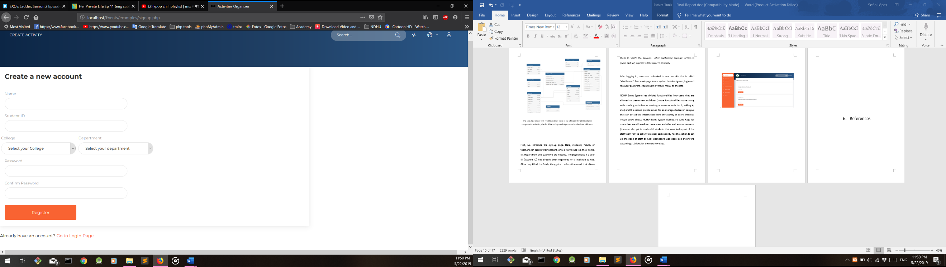First, we introduce the sign-up page. Here, students, faculty or teachers can create their account, only a few things like their name, ID, department and password are needed. The page shows if a user ID (student ID) has already been registered or is available to use. After they fill all the fields, they get a confirmation email that allows them to verify the account. After confirming account, access is given, and log-in process takes place normally.

After logging in, users are redirected to next website that is called “dashboard”. Every webpage in our system besides sign up, login and recovery password, counts with a vertical menu on the left.

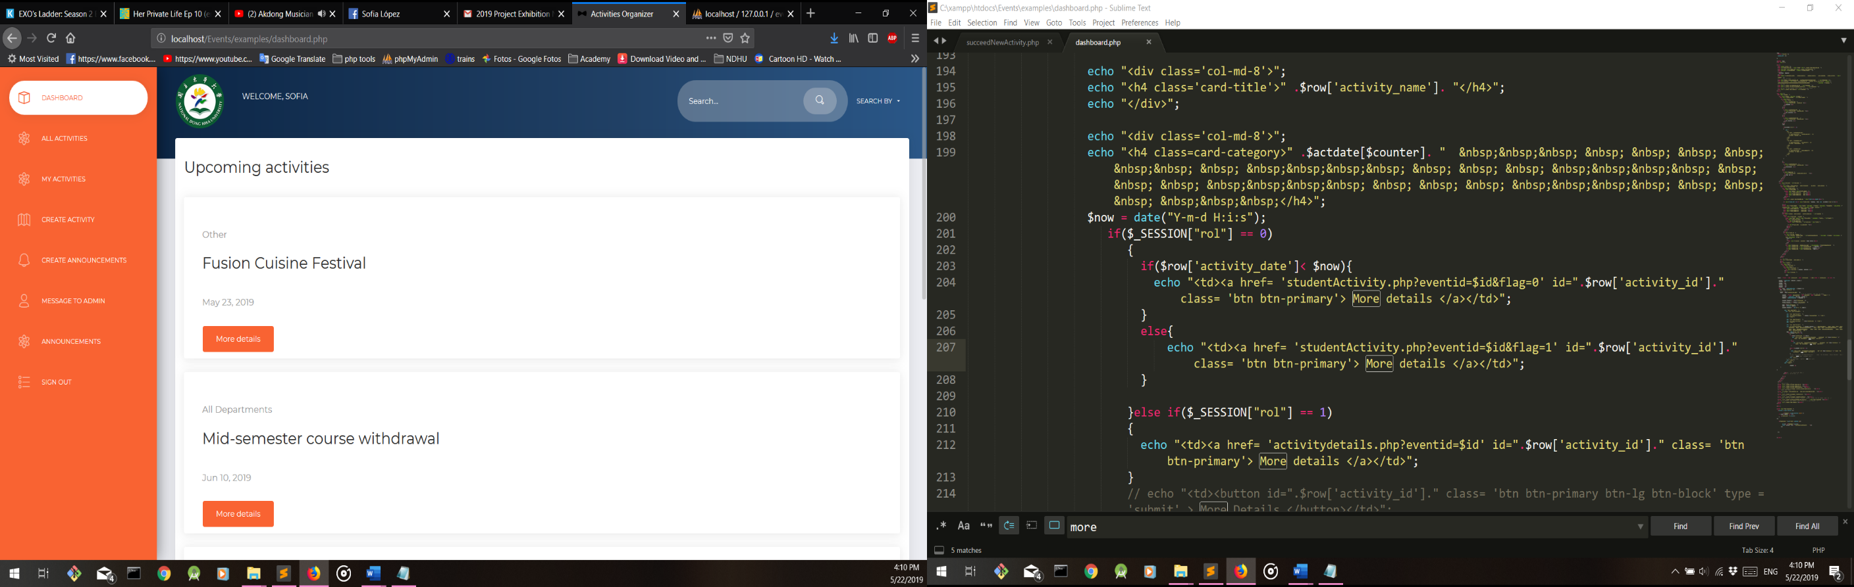NDHU Event System has divided functionalities into users that are allowed to create new activities ( more functionalities come along with creating activities as creating announcements for it, editing it, etc.) and the second profile aimed for an average student in campus that can get all the information from any activity of user’s interest. Image below shows NDHU Event System Dashboard Web Page for users that are allowed to create new activities and announcements (they can also get in touch with students that want to be part of the staff team for the activity created; each activity has the option to set up the need of staff or not). Dashboard web page also shows the upcoming activities for the next few days.

(student view of the dashboard)

The difference among teachers and student profile is the functionalities available for each of them. For students, as it is shown above, “All activities”, “my activities” and “announcements” are also visible. “All activities” shows the list of all activities that already passed or will happen in the future, “My activities” shows the list of activities that the student that has signed up for as staff member or only by attending the activity and “Announcements” are all the announcements(special comments or instructions created by teachers to alert some particular type of students) in general for all the activities. Announcements are

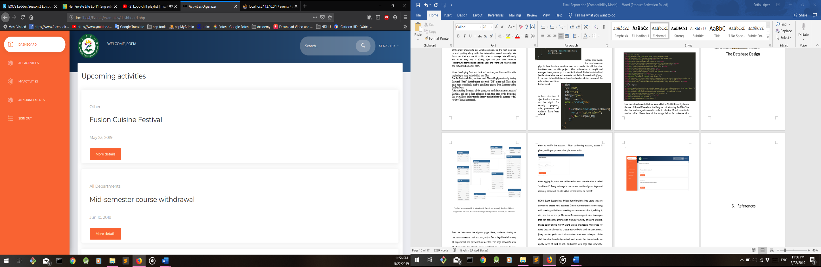shown to every student no matter department nor college.

(student view of the dashboard)

The first menu option on the left it is called “All activities” that shows all the activities that has passed already and the ones coming up. To make distinction between both, red color is used for the activities that have already passed. Black color is used for future activities.

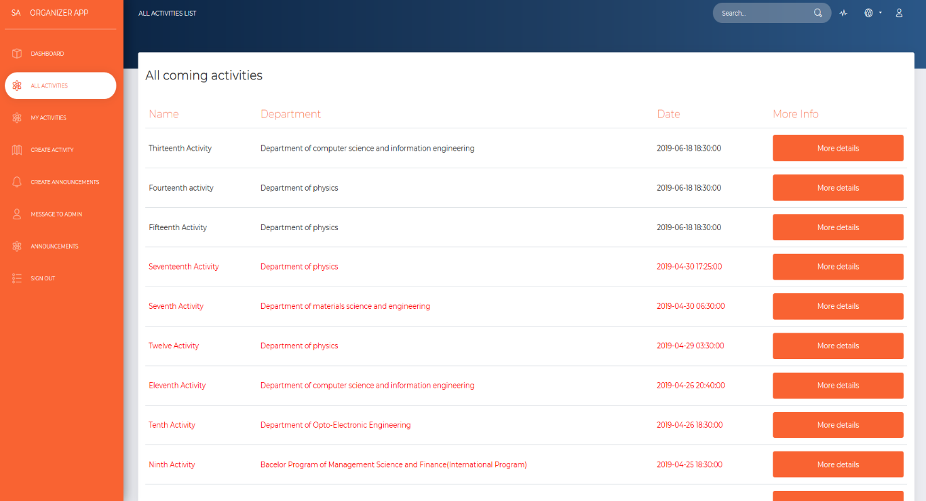

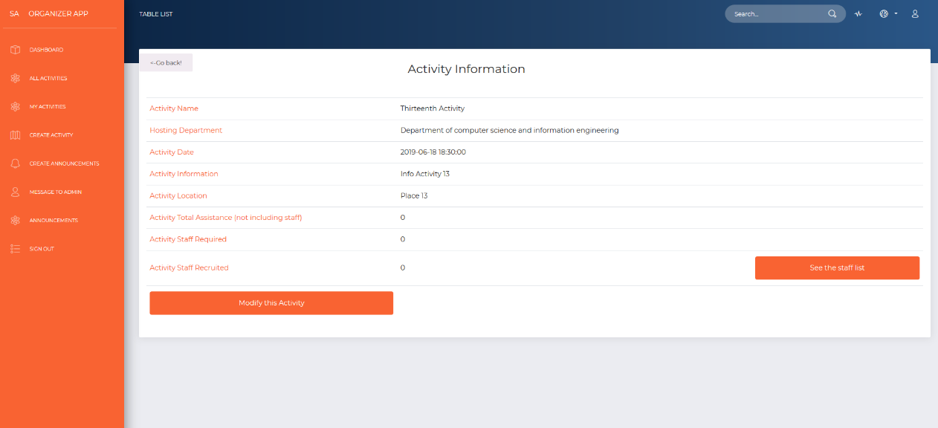Every activity has a “More Info” column with a button that will take the user to a new webpage with all the info of the activity clicked on the last page.

The image above shows the webpage that two different users will be sharing with one only difference: For the users that are allowed to create activities, if the activity the clicked on was created by them, two functions will show up on screen: the modify this activity and see the staff list buttons. For the users that did not create the activity they clicked on, the activity will detail will show as the following picture below:

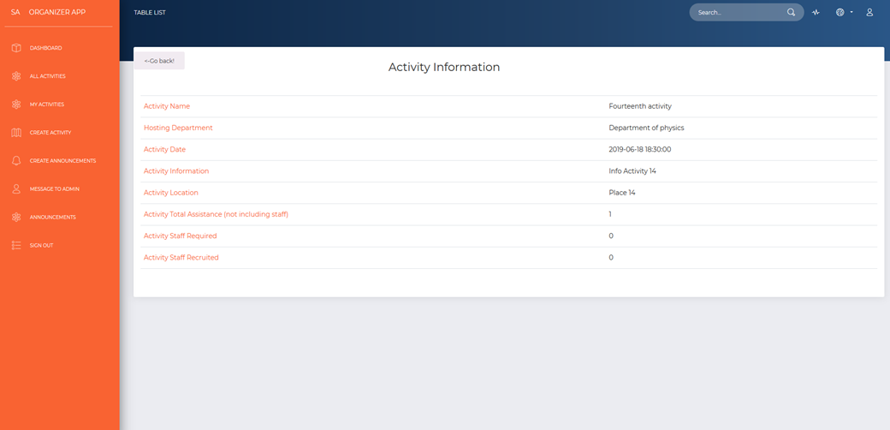

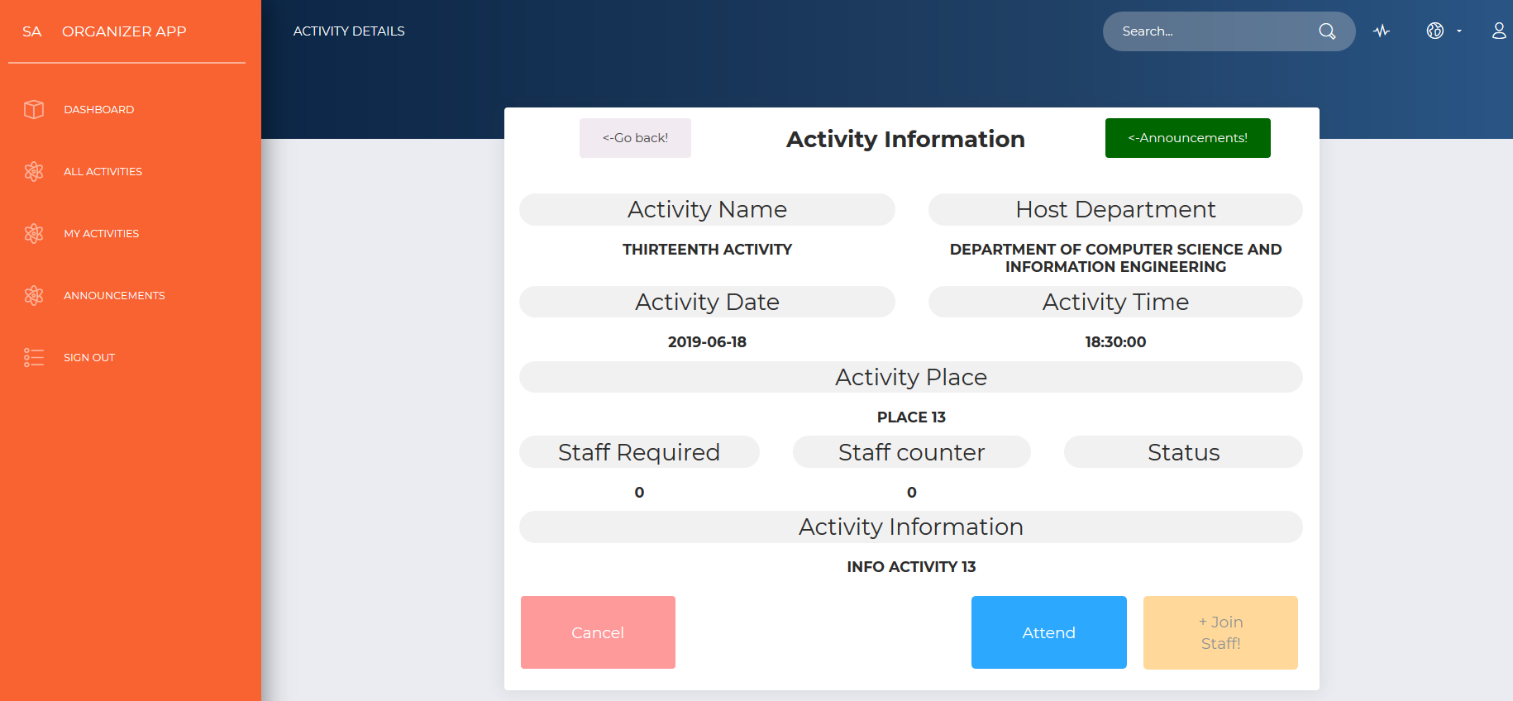

When the user wants to know more about any activity, and we know the user it is a student, the next webpage is not the ones showed in the last page. The work of verifying the user is done backstage and we redirect to the webpage shown above. There are a couple of new buttons and a different style. The student will be able to take a look to the announcements of the current activity by clicking on the red button called “Announcements” that will take the user to the list of announcements only for that activity, if any.

In this case, this activity has not been taken place yet (2019-06-18) and another functionality that has been done backstage is verifying if the student has clicked on the “Attend” button. The “Attend” button it helps us to taking into account the number of people interested in attending this activity. If the user has done that before, the “Attend” button would not be enable; in that case the “Cancel” red button would be enable and “Attend” and “+Join Staff” button would be disabled. If the “staff required number is greater than 0, the “+join staff” yellow button would be enabled. Student cannot set up the two buttons at the same time.

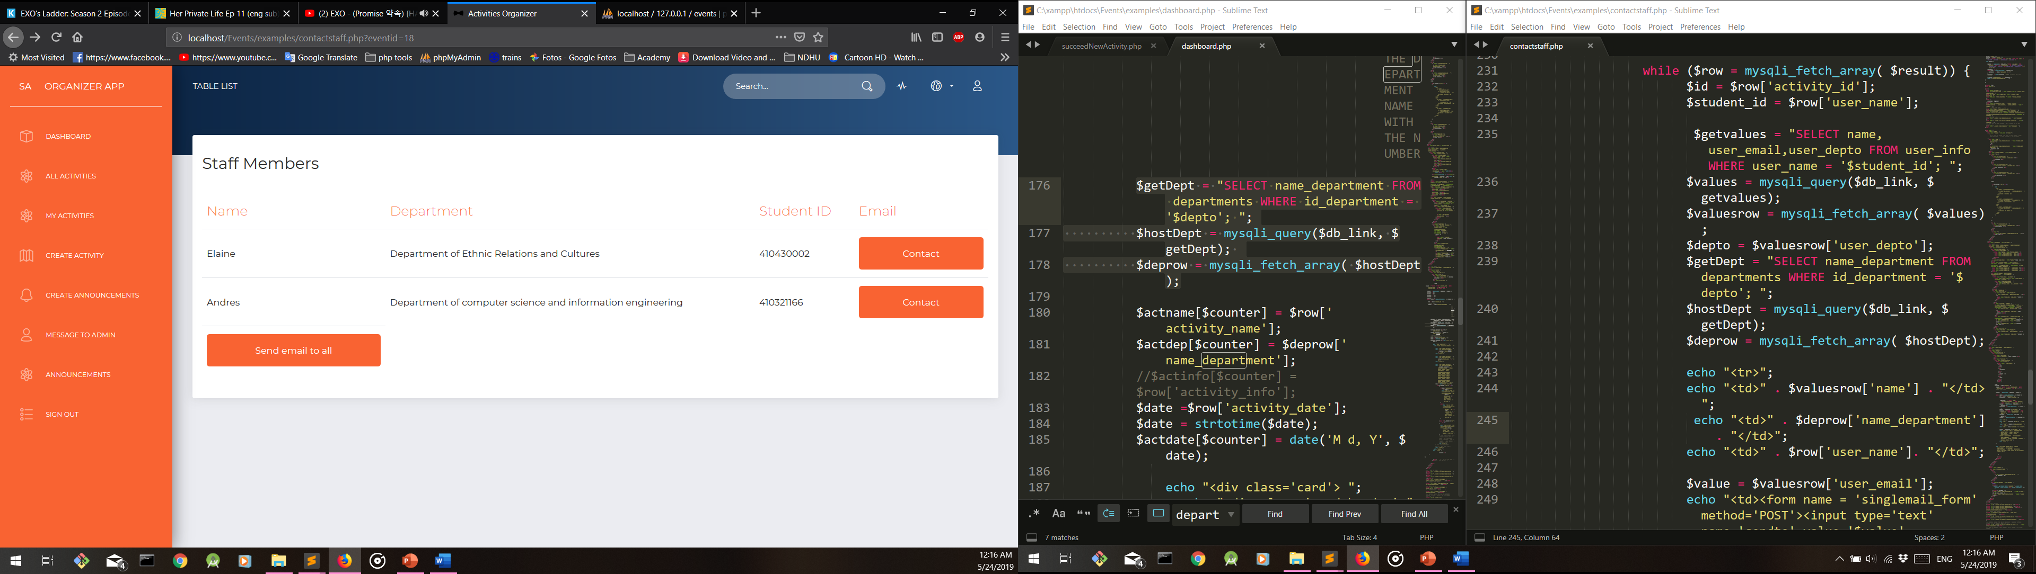Regarding seeing the list of members for the staff, the image below pictures how the creator of this activity can get in contact with the staff group by sending an email. The system will automatically send the email when the button is clicked.

Right after getting access to Staff Members list, the “send email to all” button allows us to contact all the members at the same time. The staff members will get an email from the current user (person that have created the activity, as is shown below).

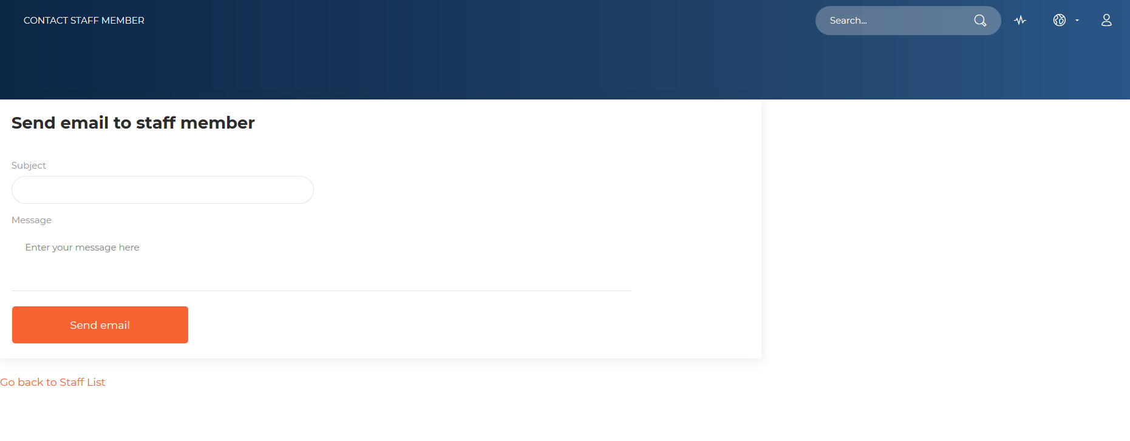

The following function on each activity details webpage is to have access to edit the information. This function is available only for the creator of the current activity (the one selected from the all activities list). The image above shows what is shown on screen right after clicking on modify this activity button.

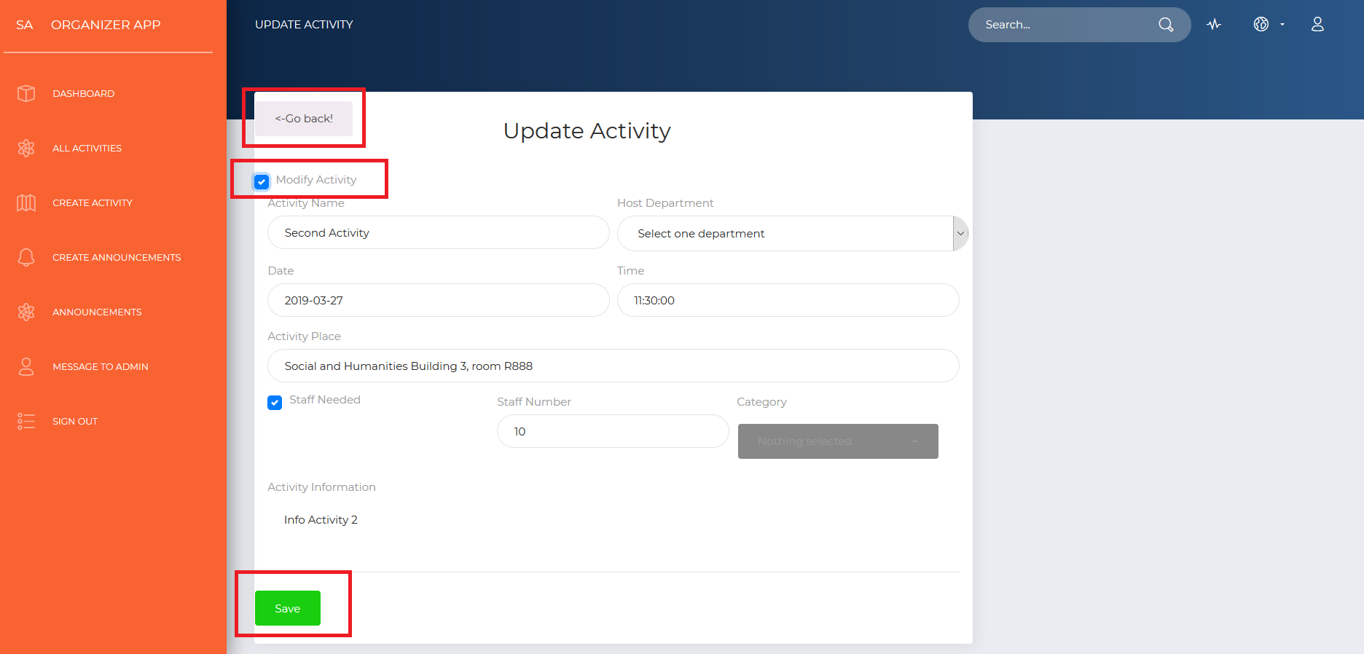

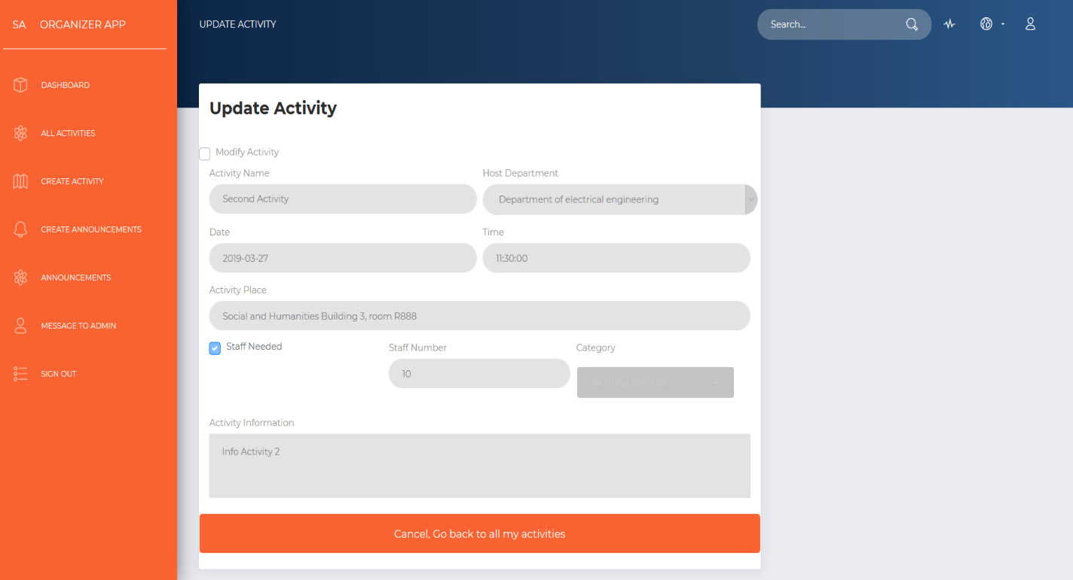

After clicking on “modify this activity”, the following webpage is a form with all the information already charged of that activity. After clicking on the “Modify Activity” checkbox, any information set up when creating it can be changed. There is also a button that will save any changes made in the information. If there is any change made but we do not want to save, in other words we would like to leave it as we found it, we click again on “modify activity” checkbox again.

The gray button that has been squared in red, takes us back to the webpage where the details of the activity are displayed. After making any change, click on “save” button, and changes will be made right away.

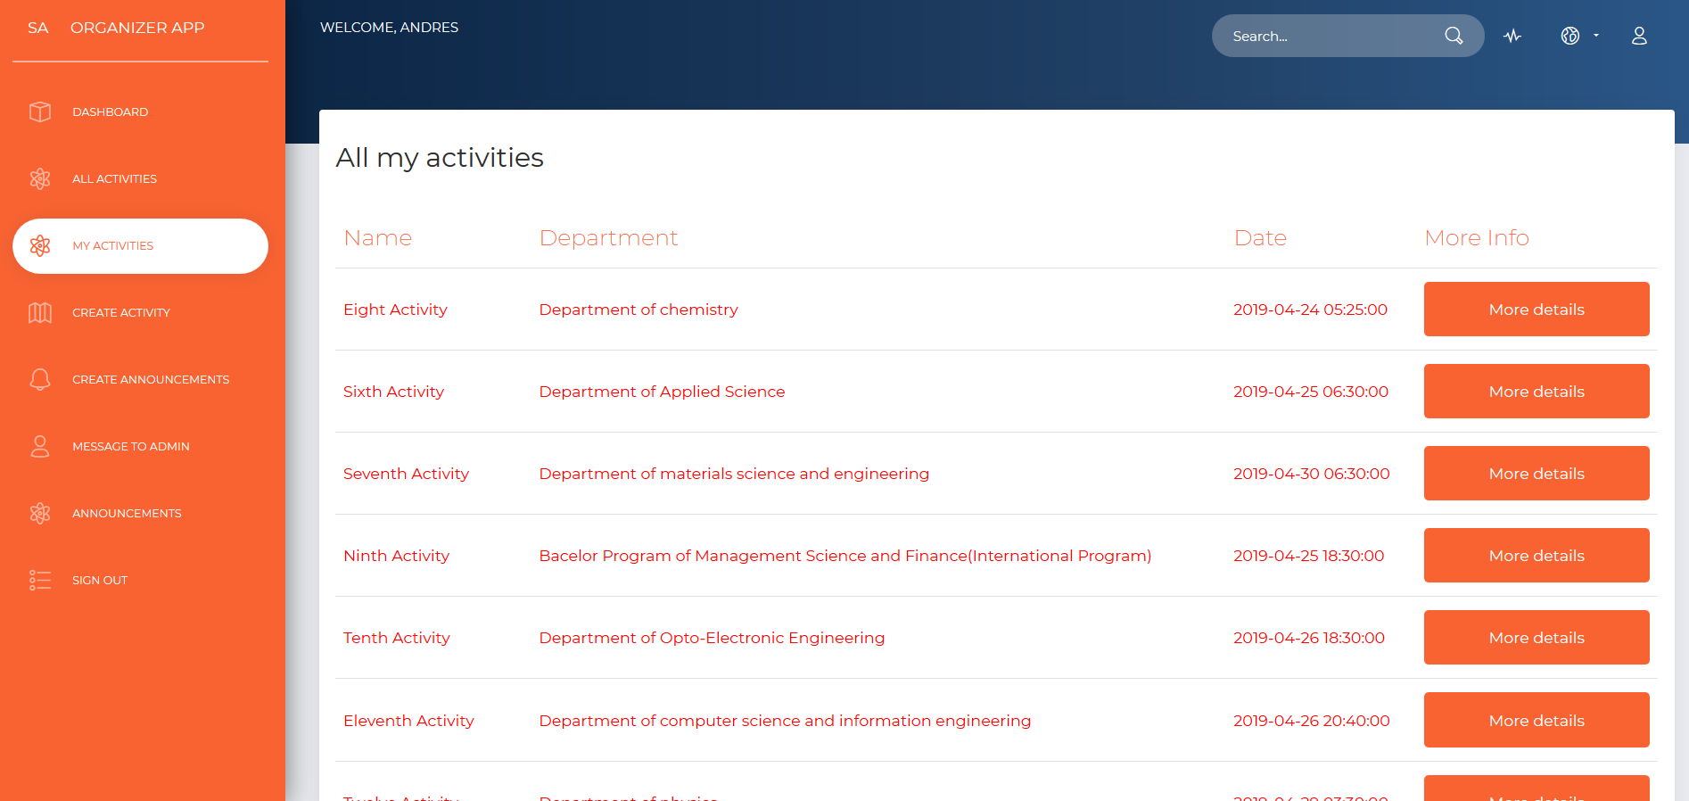

We also allow the user to display the activities that he/she has created before. The color red is used for the activities that has already taken place. As in the “All activities” section, “My activities” section also has the “more Info” column that has a “more details” button on it.

After clicking on the “More details” button, it redirects direct to the same web-page as with the button in “all activities” page.

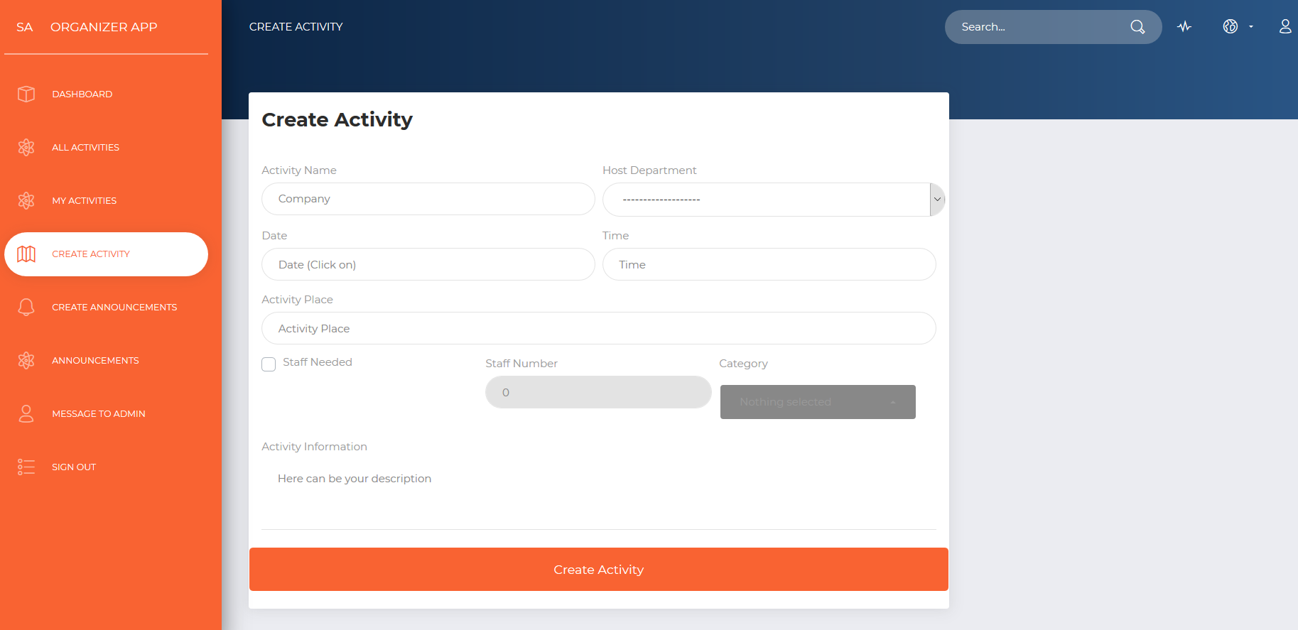

For creating any activity at NDHU Event System, a couple of data is required to be filled as: Activity Name, Host Department (that will be chosen and no need to type it in), Activity Date (Chosen from a Jquery datepicker), time (also Chosen from a Jquery Clockpicker), activity place (the place where it will be held at), a check-box for staff (that not only tells us if staff will be needed but will also eliminate the ‘disabled’ attribute from the “staff number” HTML Input), staff number (if the checkbox was checked, category of the activity (more than one can be chosen) and a brief description of the activity.

When filling up the new Activity Form, one HTML element that is quite different from the others in an average form is the datepicker. The calendar can be displayed only by clicking on any part of the Date input.

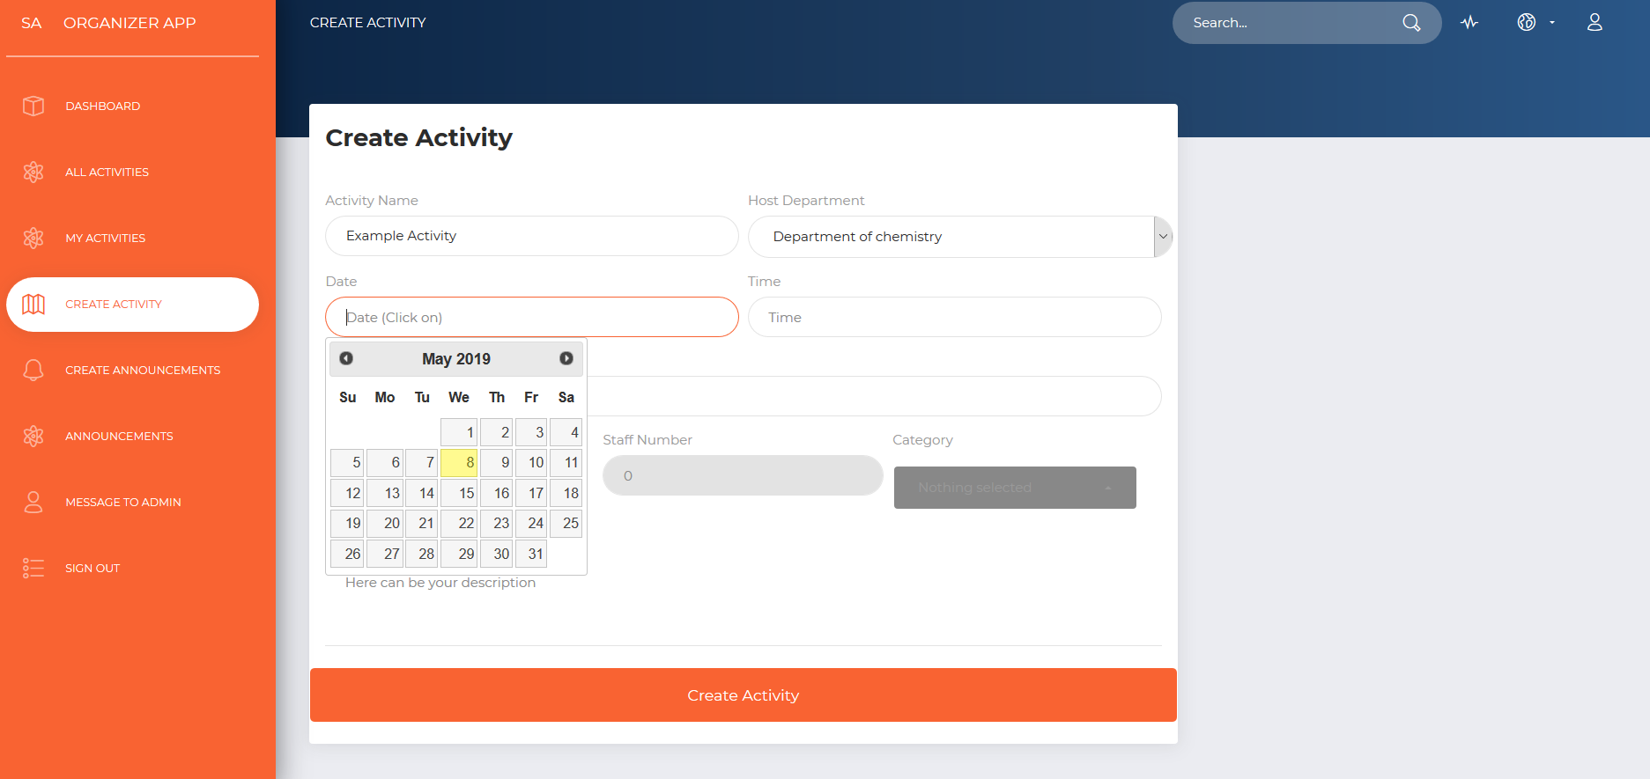

Activity time is a must when filing up all the information for the new activity. When choosing the hour, automatically minutes will show up on screen and we only need to click on the minutes and finally click on the border at the inferior bottom of the clock pop-up.

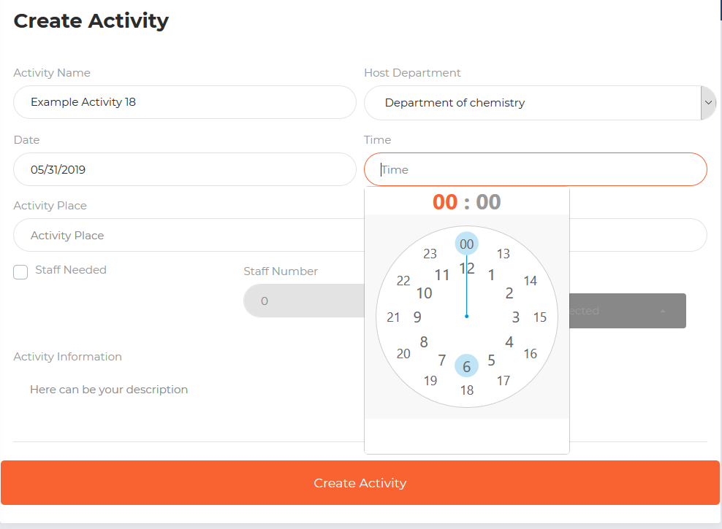

The following image shows how to choose different categories at the same time for the new activity.

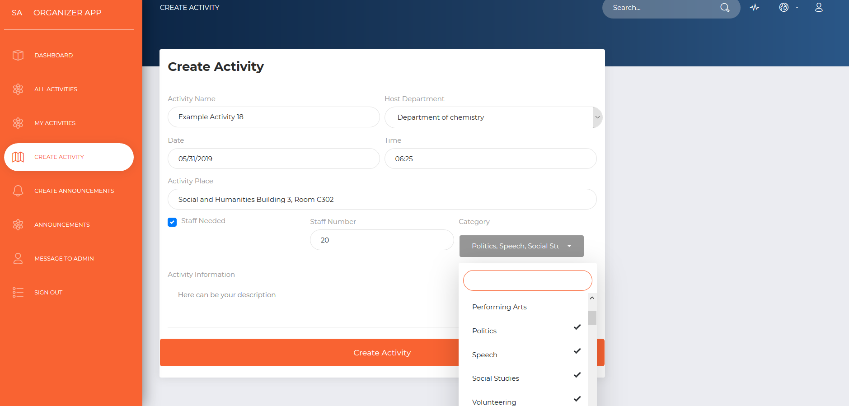

After finish filling up all the information required, click on “Create Activity” button, and automatically all information will be saved in the database and can be checked on “My activities” list.

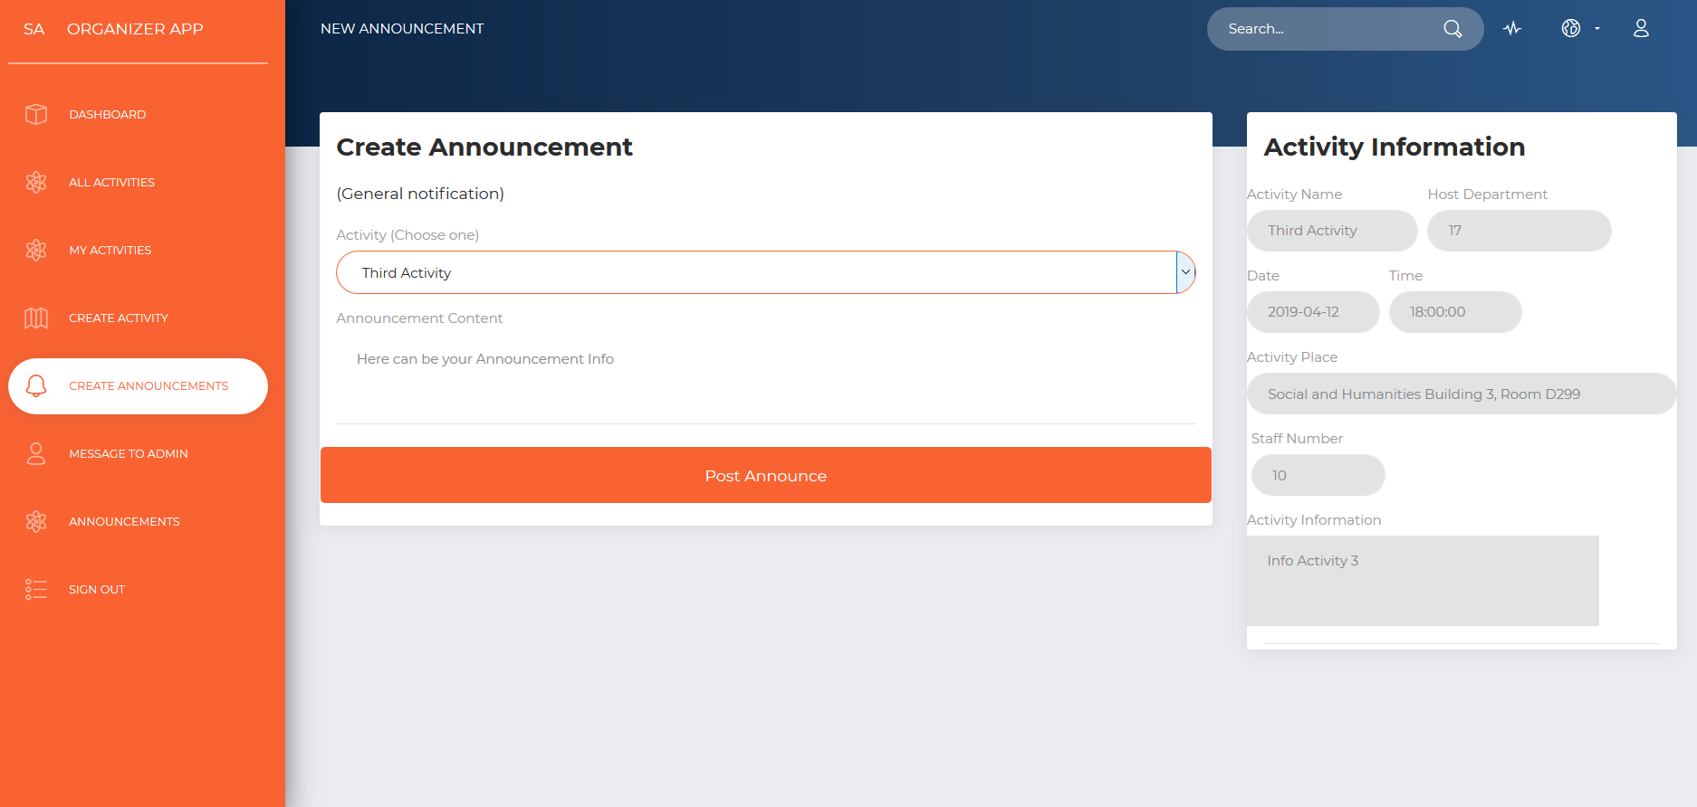

When creating an announcement, when can access to the webpage above by clicking on the menu on the left by clicking on “create announcements”. Every announcement has to be related to one activity. In order to choose an activity from the list of activities created, the user has to click on the dropdown with the name of “Activity” and after that, all the information from the activity will be displayed on the right “Activity Information” section. The last step is to write down the announcement or reminder for the activity selected from the dropdown above.

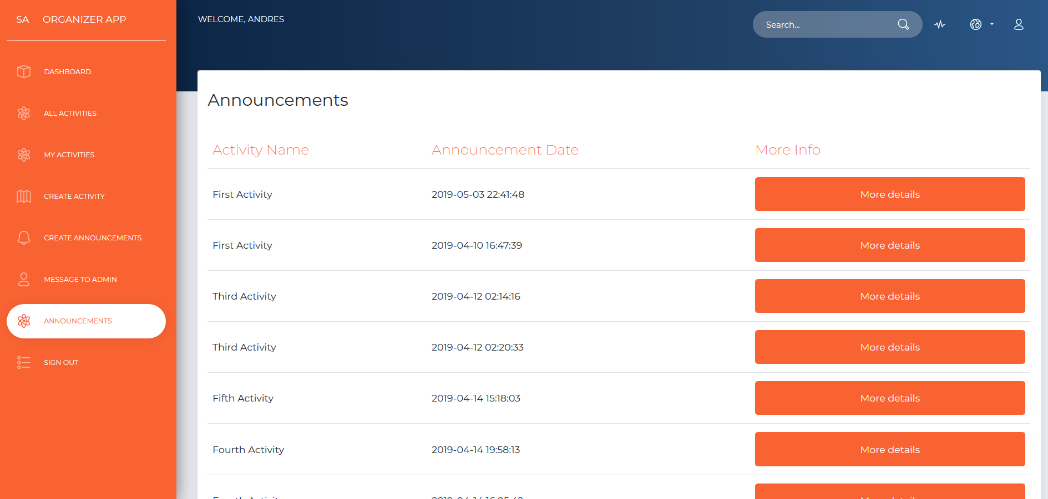

In order to see the details from any announcement, we can access directly the link in the menu on the left called “Announcements” and the list of all the announcements will be displayed on the right; and right after getting the whole list, click on any “More details” button that will takes us to the details of the activity and to the display of all the details from the announcement (as is shown below)

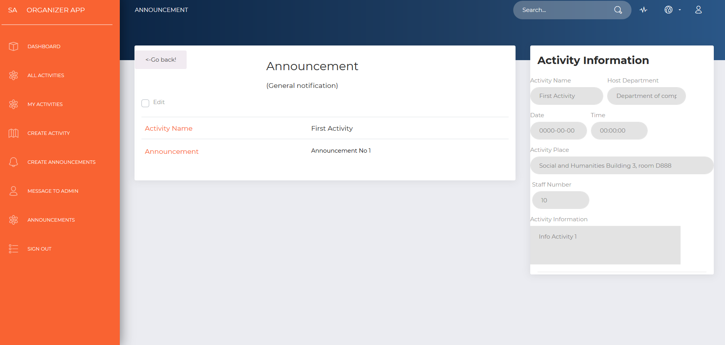

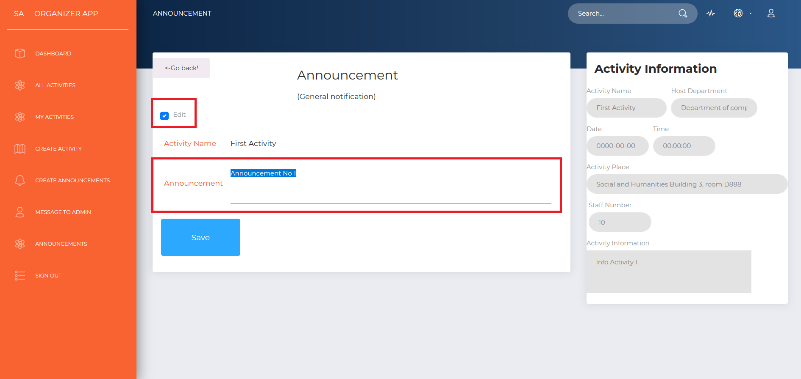The square in red on the top left corner indicates that after checking the “Edit” checkbox, the label that contains the announcement information, will be transformed into a text area where the value can be changed, and also a light blue button at the bottom will show up to save changes. As in modifying the activity, if changes are not saved, but instead the edit checkbox is clicked for the second time, the text area will be transformed back into label with the original value in the text. Refer to the image below for more details.

After saving changes, the webpage is refreshed with the new content for the announcement and the text area goes back to label.

This has been a very general introduction and explanation of the website’s most important and useful features.

**6. Conclusion**

NDHU Event System aims to solve the problem of making information difficult to access for some students on campus. Through all the different features like seeing all events in general or being able to search by date, department, etc. and options that the system offers we hope it can be very useful and improve the way information is managed and distributed in NDHU.

It can also give a better picture of what students are interested in by the feature of “attend” in which a student shows his/her interest in any specific event. This allows school to have a better understanding what students are interested. So overall it can create a better interaction between NDHU faculty and students.

**7. References**

* Learning PHP, MySQL & JavaScript 4th Edition– Robin Nixon
* <https://jqueryui.com/>
* [https://www.w3schools.com](https://www.w3schools.com/bootstrap4/default.asp)